**Microservice Template for VS**

**Clean architecture (Onion architecture)**

[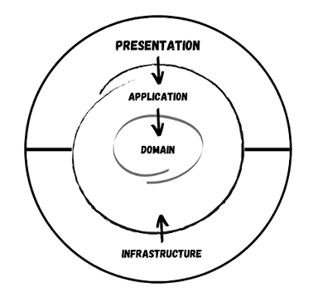](https://user-images.githubusercontent.com/15936780/145341846-6e486db8-cc89-48c7-b0b8-e76245e9a90c.png)

**Domain**

* Entities
* Value Objects
* Enumerations
* Enterprise Logic
* Exception

**Applications**

* Interfaces
* Models (DTO, ViewModels and etc)
* Application Logic
* Commands
* Queries
* Validators
* Exceptions

**CQRS**

* Command Query Responsibility Segregation
* Separate reads (queries) and writes (commands)
* Can maximise performance, scalability, and simplicity
* Easy to add new features, just add a new query or command
* Easy to maintain, changes only affect one command or query

**CQRS + MediatR**

* Define commands and queries as requests
* Application layer is just a series of requests/response objects
* Ability to attach additional behaviour before and/or after each request. Example: logging, validation, caching, and etc.

**Key points**

* Using CQRS + MediatR simplifies your overall design
* MediatR simplifies cross cutting concerns
* Fluent Validation is useful for all validation scenarios
* AutoMapper simplifies mapping and projections
* Independent of infrastructure and data access concerns.

**Infrastructure**

* Persistence
* Identity
* File System
* API Clients
* Blob storage

**How to generate the Microservice solution?**

The below steps helps to to create a Microservice project using the WSA.Microservice.Template project template.

1. Copy and paste the WSA.Microservice.Template .zip file into the Visual Studio Project Templates folder.

..\Visual Studio 2022\Templates\ProjectTemplates

1. Open Visual Studio and choose to create new project
2. Search for WSA templates in the Search

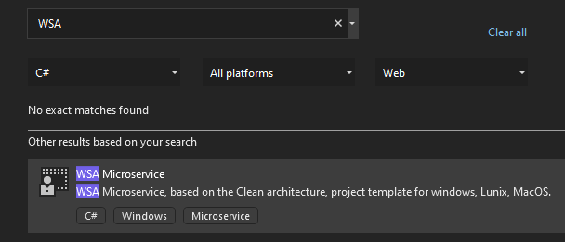

1. Select the WSA Microservice and click Next
2. Enter your Microservice name and other details and click Create

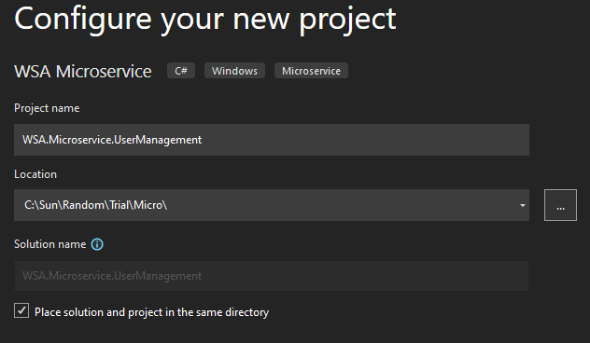

1. Above step will create the Microservice project solution which created based on the Clean architecture as below.
2. Build the Solution and start exploring the project structure which is designed based on the Clean architecture. Once you’re familiar with the architecture create your own features and remove the sample feature, Todo feature, which comes with the template.

